Seite: Our Work - Archiv von noch nicht veröffentlichter Version aus dem HostEurope Editor

Screenshot 1:

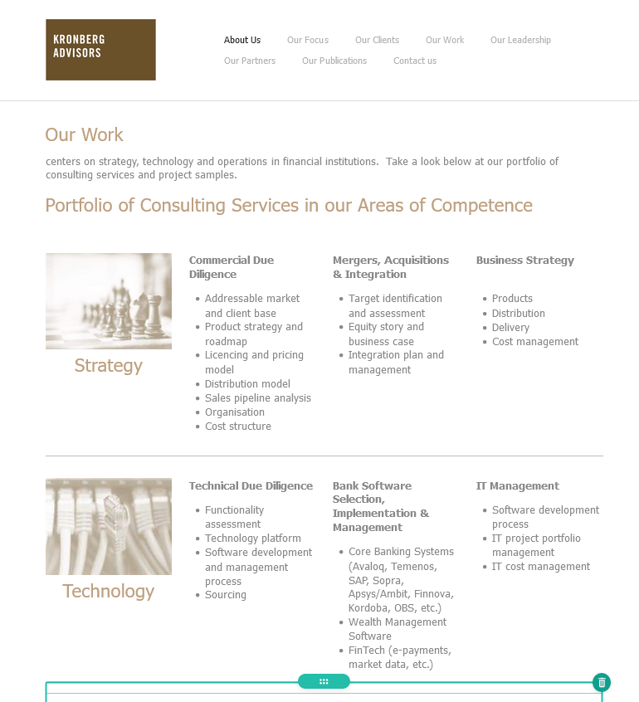

Screenshot 2:

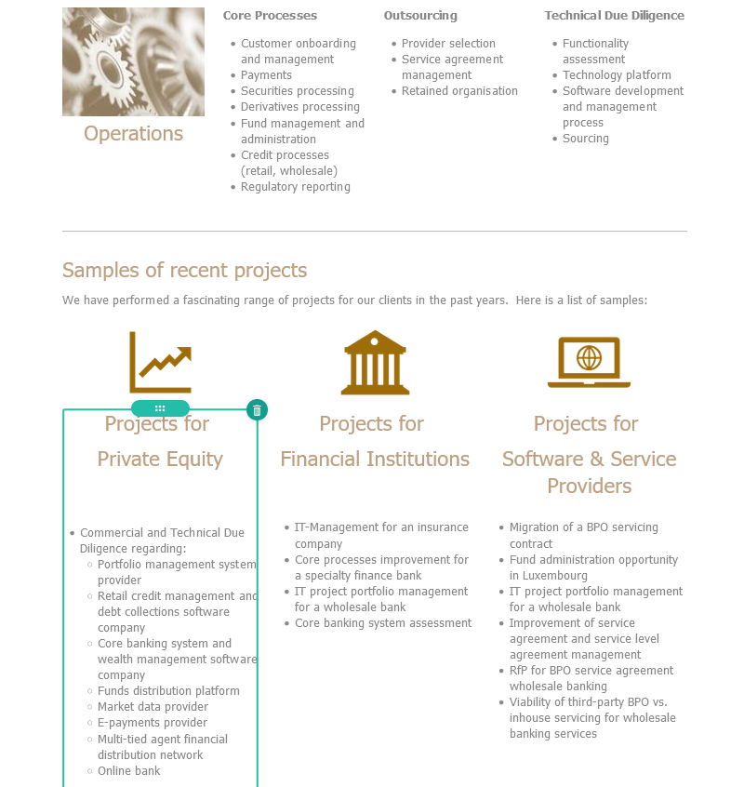

Screenshot 3:

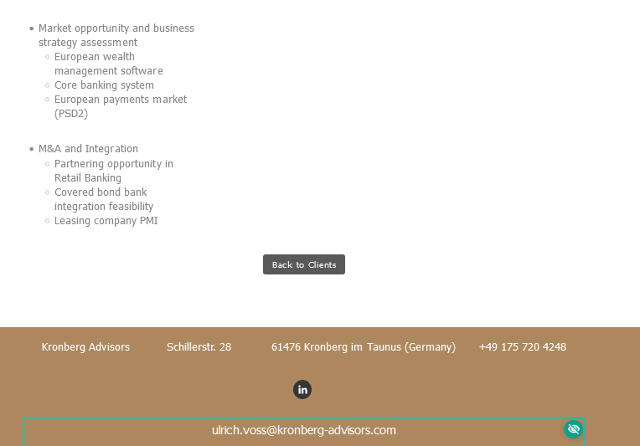

Text 1:

# Our Work

centers on strategy, technology and operations in financial institutions. Take a look below at our portfolio of consulting services and project samples.

Text 2:

Portfolio of Consulting Services in our Areas of Competence

Bild 1:



Text 3:

Strategy

Text 4:

**Commercial Due Diligence**

* Addressable market and client base
* Product strategy and roadmap
* Licencing and pricing model
* Distribution model
* Sales pipeline analysis
* Organisation
* Cost structure

Text 5:

**Mergers, Acquisitions & Integration**

* Target identification and assessment
* Equity story and business case
* Integration plan and management

Text 6:

**Business Strategy**

* Products
* Distribution
* Delivery
* Cost management

Bild 2:



Text 7:

Technology

Text 8:

**Technical Due Diligence**

* Functionality assessment
* Technology platform
* Software development and management process
* Sourcing

Text 9:

**Bank Software Selection, Implementation & Management**

* Core Banking Systems (Avaloq, Temenos, SAP, Sopra, Apsys/Ambit, Finnova, Kordoba, OBS, etc.)
* Wealth Management Software
* FinTech (e-payments, market data, etc.)

Text 10:

**IT Management**

* Software development process
* IT project portfolio management
* IT cost management

Bild 3:



Text 10:

Operations

Text 11:

**Core Processes**

* Customer onboarding and management
* Payments
* Securities processing
* Derivatives processing
* Fund management and administration
* Credit processes (retail, wholesale)
* Regulatory reporting

Text 12:

**Outsourcing**

* Provider selection
* Service agreement management
* Retained organisation

Text 13:

**Technical Due Diligence**

* Functionality assessment
* Technology platform
* Software development and management process
* Sourcing

Text 14:

Samples of recent projects

Text 15:

We have performed a fascinating range of projects for our clients in the past years. Here is a list of samples:

Text 16:

# Projects for

# Private Equity

* Commercial and Technical Due Diligence regarding:
* + Portfolio management system provider
  + Retail credit management and debt collections software company
  + Core banking system and wealth management software company
  + Funds distribution platform
  + Market data provider
  + E-payments provider
  + Multi-tied agent financial distribution network
  + Online bank
* Market opportunity and business strategy assessment
* + European wealth management software
  + Core banking system
  + European payments market (PSD2)
* M&A and Integration
* + Partnering opportunity in Retail Banking
  + Covered bond bank integration feasibility
  + Leasing company PMI

Text 17:

# Projects for

# Financial Institutions

* IT-Management for an insurance company
* Core processes improvement for a specialty finance bank
* IT project portfolio management for a wholesale bank
* Core banking system assessment

Text 18:

# Projects for

# Software & Service Providers

* Migration of a BPO servicing contract
* Fund administration opportunity in Luxembourg
* IT project portfolio management for a wholesale bank
* Improvement of service agreement and service level agreement management
* RfP for BPO service agreement wholesale banking
* Viability of third-party BPO vs. inhouse servicing for wholesale banking services

Button 1:

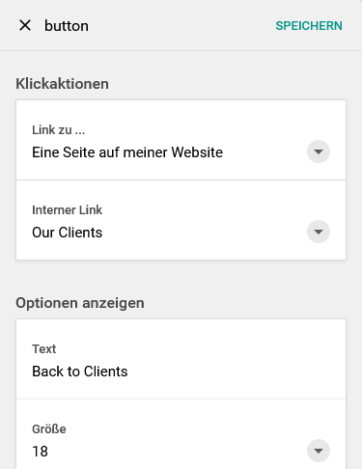

Adresszeile, LinkedIn und E-Mailadresse identisch wie bei “About Us”